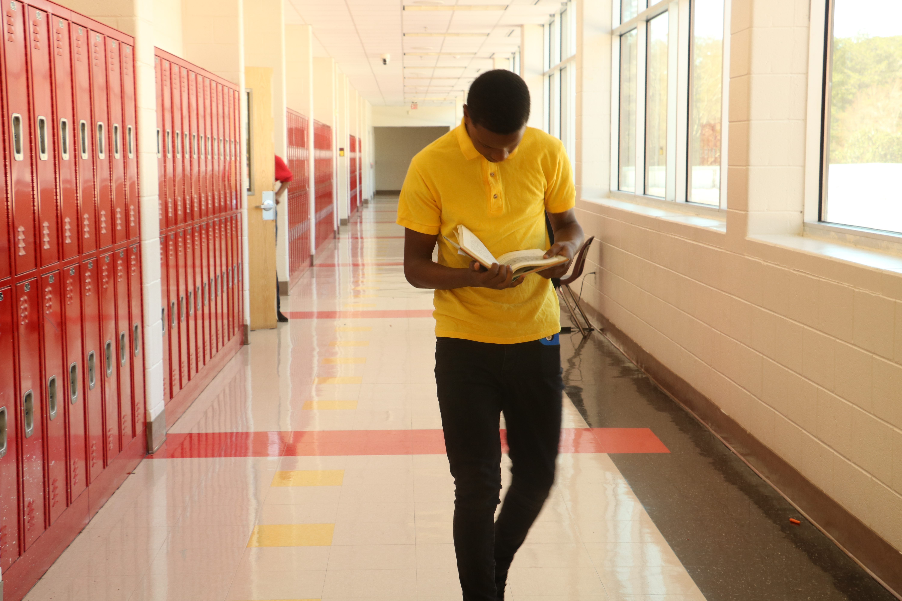 |  | What is a School-Parent Compact?  Our annual school-parent compact offers ways that we can work together to help our students succeed. This compact provides strategies to help connect learning at school and at home. Effective compacts:  - Link to academic achievement goals  - Focus on student learning  - Share strategies that staff, parents, and students can use  - Explain how parents and teachers can communicate about student progress  - Describe opportunities for parents to observe, volunteer, and participate in the classroom |  | 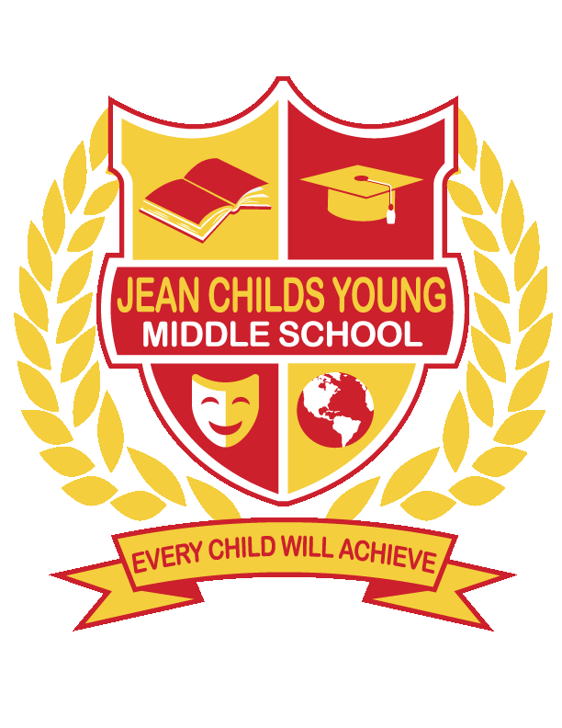
Communication About Student Learning  Jean Childs Young Middle School (JCYMS) is committed to regular two-way communication with families about their student’s academic success. Some of the ways that families may expect us to reach you are:  - Weekly homework folders  - Notes or phone calls  - Updates on the school website  - Parent-Teacher conferences  Parents may contact us via email at jeanchildsyoungmiddleschool@atlanta.k12.ga.us or contacting their child’s teacher via email or phone. |  | Jointly Developed  Parents, students, and staff worked together and shared ideas to develop the school-parent compact. Meetings are held each year to review and revise the compact based on the school’s academic achievement goals and students’ needs. Parents are welcome to provide feedback on the compact at any time during the school year. All feedback will be collected and reviewed during the annual revision meeting with parents.  Please call 404-802-5900 or visit our website, www.atlantapublicschools.us/young for more information on the school-parent compact. |  | Young Middle School  School-Parent Compact  2024-2025  3116 Benjamin E. Mays Drive, SW  Atlanta, GA 30311  404-802-5900  www.atlantapublicschools.us/young  Revised: August 24, 2024

Student Academic Agreement  As a student, I am committed to succeeding in school. In effort to reach my goals, throughout the school year, I will:  - Do my homework daily using a variety of resources to complete each task.  - Participate in tutorial offered at school.  - Read at least 30 minutes every day outside of school using a variety of genres, including fiction books of interest and non-fiction books to increase learning.  Parent Academic Agreement  As a parent/guardian, I am committed to supporting my child(ren) learning. Throughout the school year, I will:  - Attend Open House, PTA, Academic Nights, and support the academic curriculum of the school through visits to my child’s classroom and volunteering.  - Visit the Parent Center to attend workshops and utilize their resources.  - Provide real-life experiences to reinforce their child’s knowledge of subject content matter.  - Create a comfortable learning space and literate rich home environment.  Building Family Partnerships  Family partnerships are vital to our school community and our school’s culture. Young Middle School builds partnerships between the home and school by educating teachers, administration, and other staff by gathering input from families on how to communicate and work with families as equal educational partners. We invite families to connect with us during parent academic events outlined in our Family Engagement Plan. |  |  |  | Academic Achievement Goals  JCY Mission  The mission of Young Middle School is to prepare students to be globally competitive through rigorous and equitable instruction, a continuum of care and services, and active partnerships with parents and community stakeholders.  JCY Vision  Young Middle School will be a high performing IB school of choice where students want to learn, parents and families engage, educators empower students to succeed, and the community collaborates with the school to rebuild the legacy.  School Goals:  During the 2023-2024 school year as measured by Milestones, level 3 and up will:  - As measured by Milestones, ELA-Lvl 3 and up will increase from 17% to 20% and (Lvl 2 and up) will increase from 48% to 51%  - As measured by Milestones, Math-Lvl 3 and up will increase from 13% to 16% (Lvl 2 and up) will increase from 47% to 50%  - Increase ADA from 87.8% to 90% by May 2024.

School Academic Agreement

Young Middle School (JCYMS) strives is to provide a supportive learning environment which fosters intellectual, social-emotional and creative growth in order to prepare every student for college and career. Throughout the school year, we will:

- Provide a variety of resources and activities to strengthen problem solving skills and the understanding of mathematical operations and reasoning.

- Provide a variety of resources and activities to increase reading comprehension and vocabulary for students in 3rd-5th grade.

- Provide real-life experiences to enhance in-depth understanding of standards for Science and Social Studies.

